**Main Menu of Admin User**

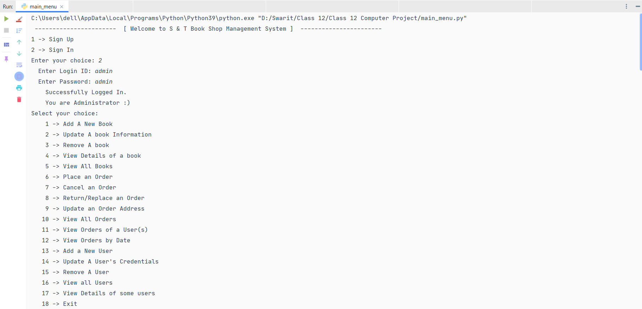

**Adding a Book**

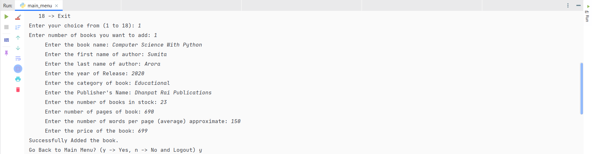

**Updating a Book**

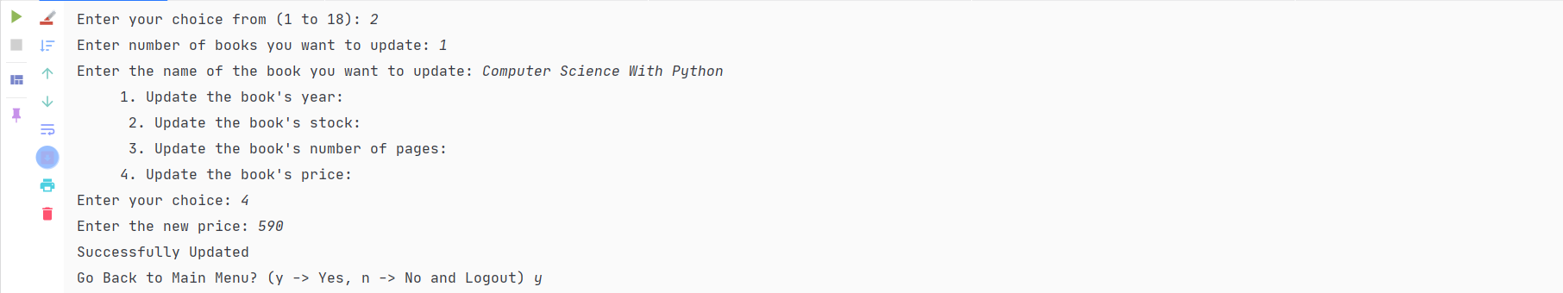

**Deleting a Book**

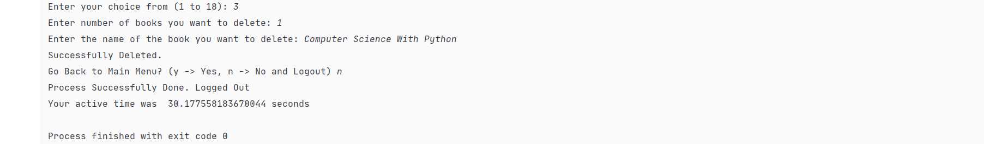

**Adding Users**

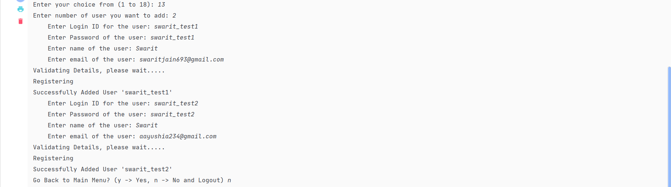

**Updating Users**

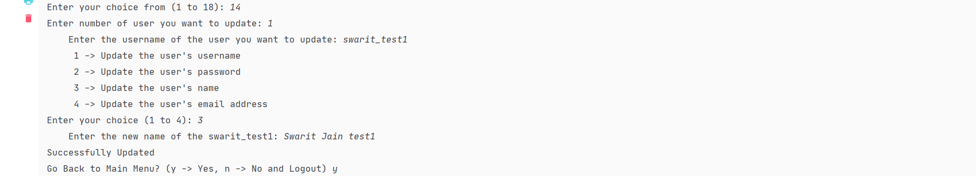

**Removing User**

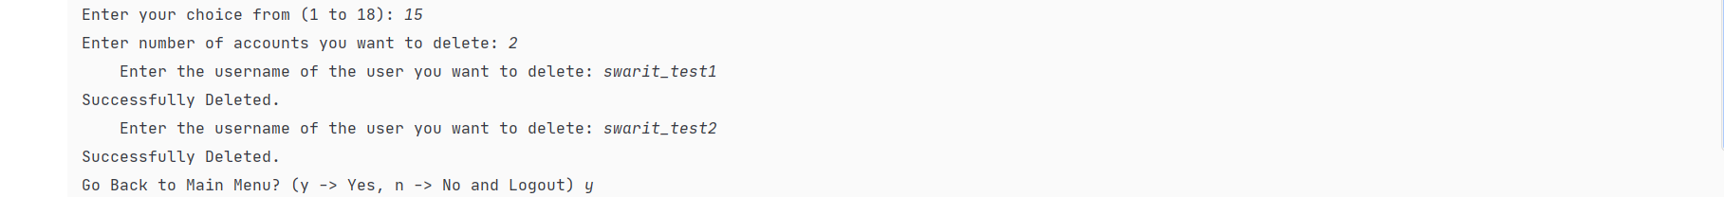

**View All Users**

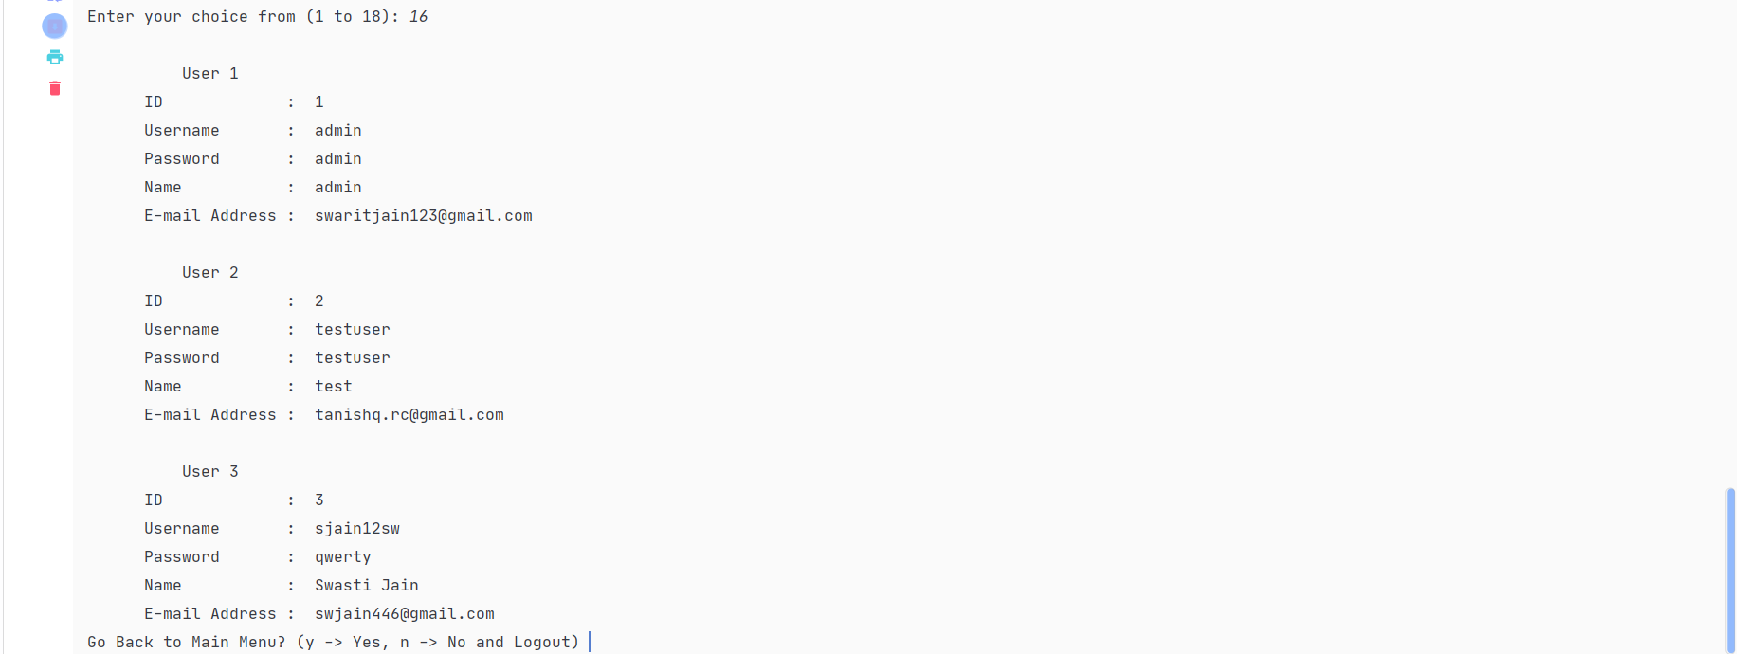

**View Details of a Particular User**

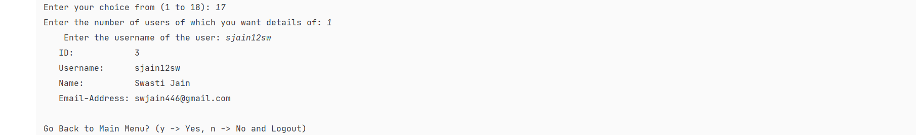

**Returning an Order**

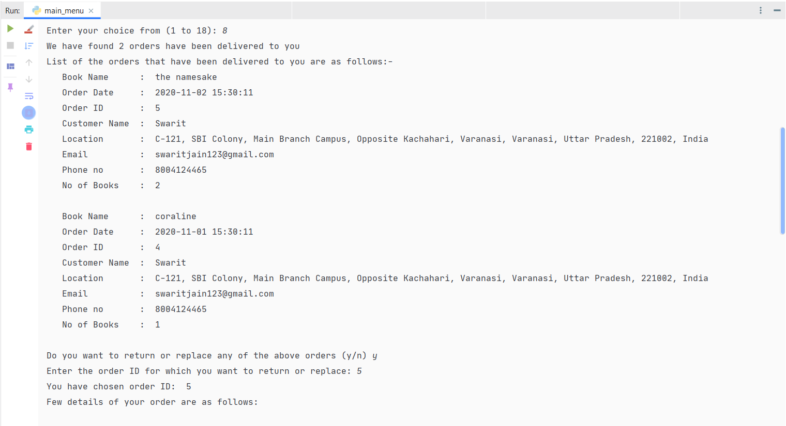

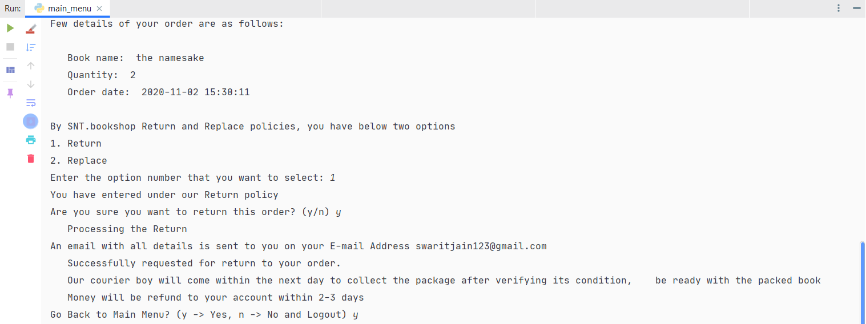

Note: - Orders Shown here are test orders of ‘admin’ user which were inserted after the testuser (sjain12sw) placed his/her order. Two Orders displayed above are used one by one for return and replacement.

**P.T.O.**

**Email sent on Returning the order**

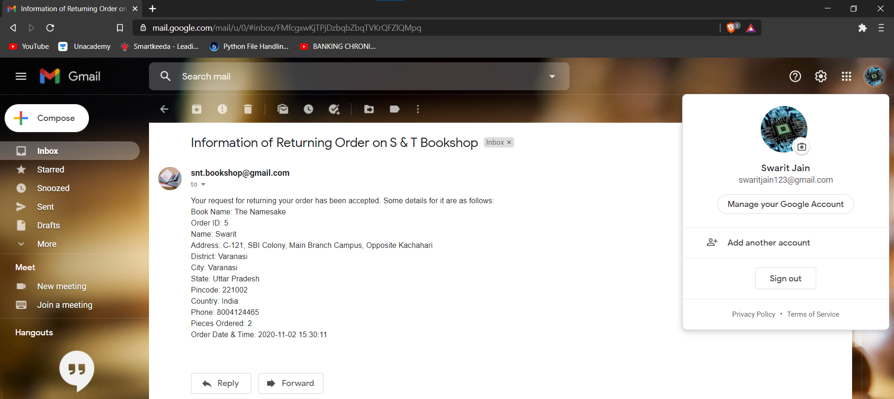

**P.T.O.**

**Replacing an Order**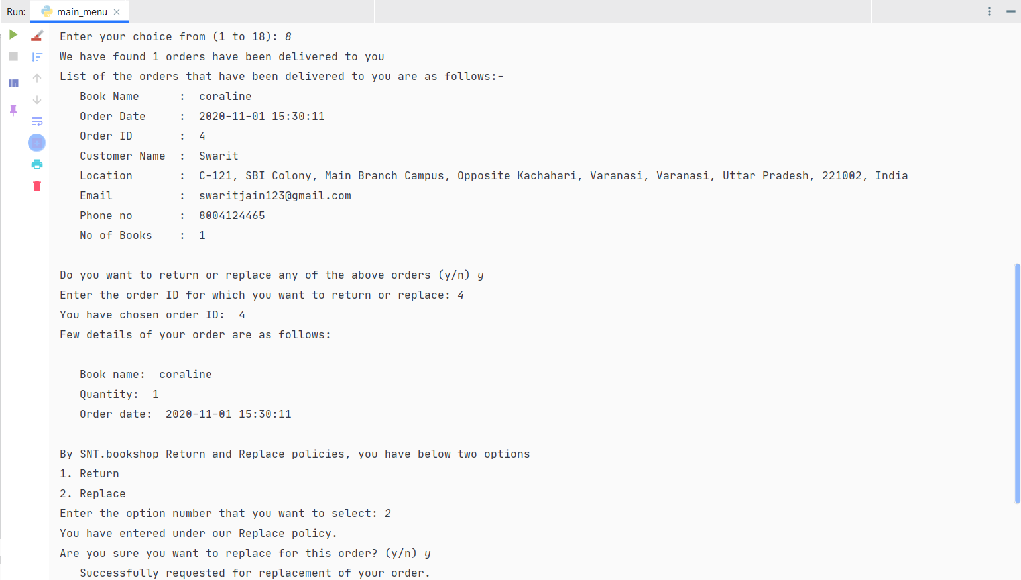



**Email Sent on Replacing the Order**

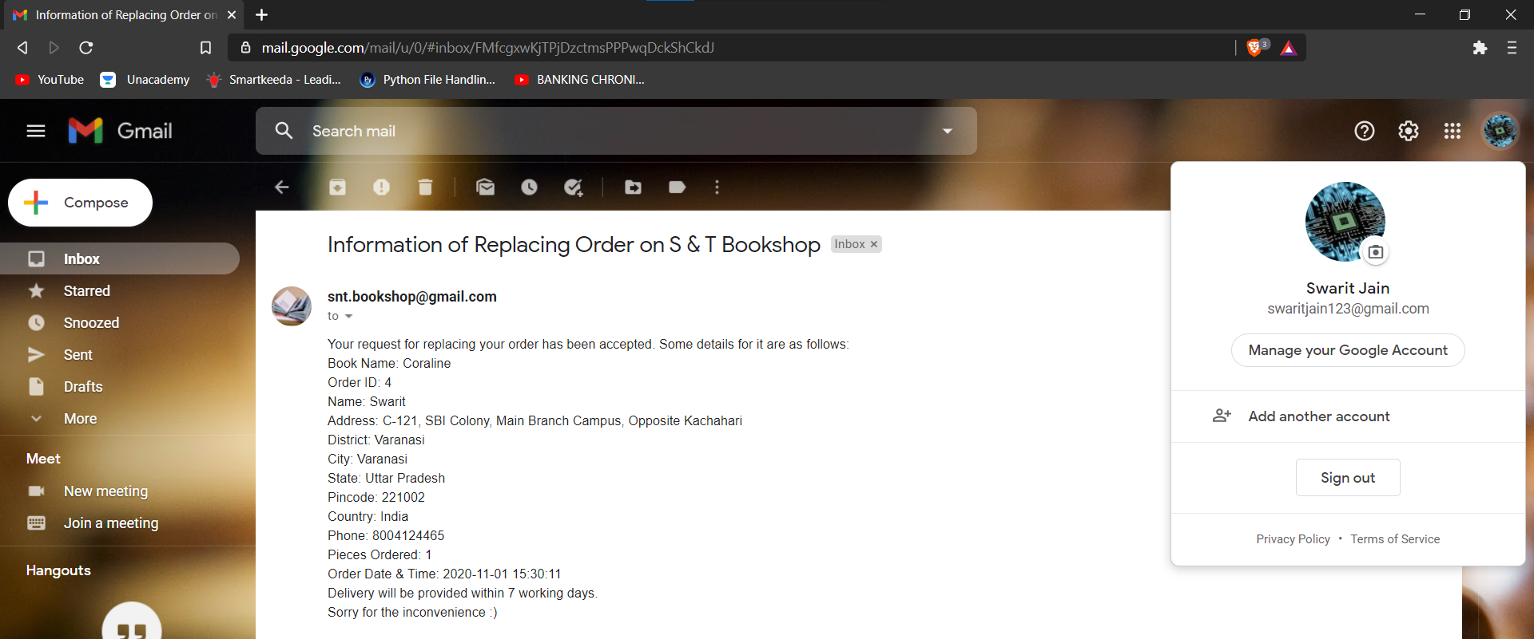

**Viewing all Orders for Replacement**

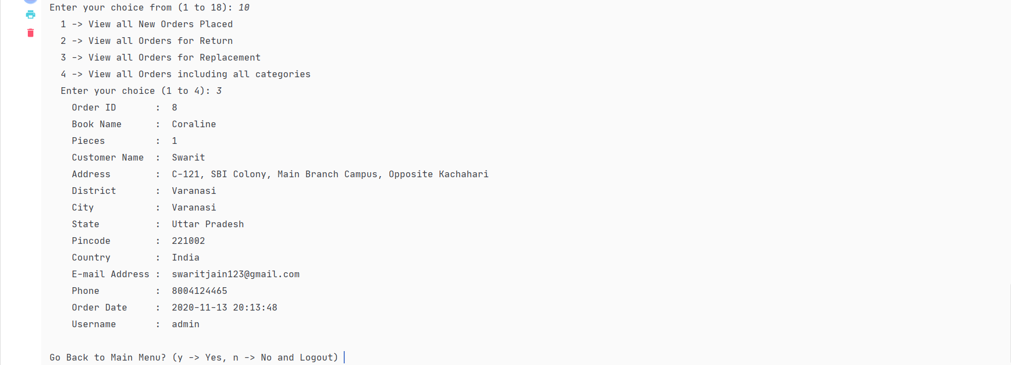

**P.T.O.**

**Viewing all Orders for Return**

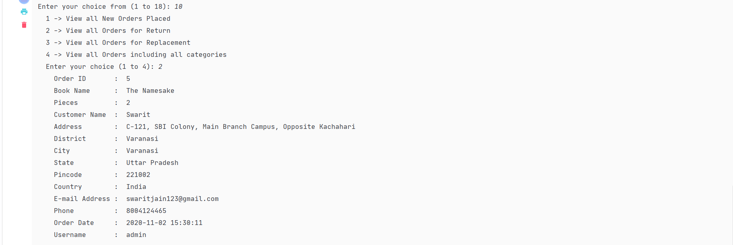

**P.T.O.**

**Viewing all Orders of a particular User (**here, admin**)**

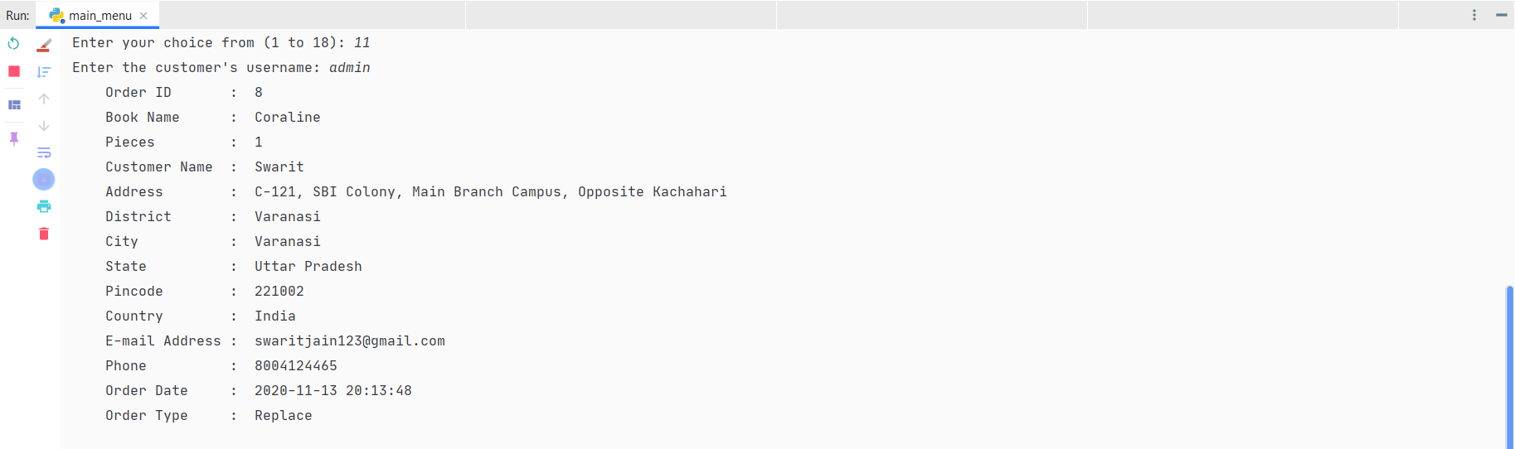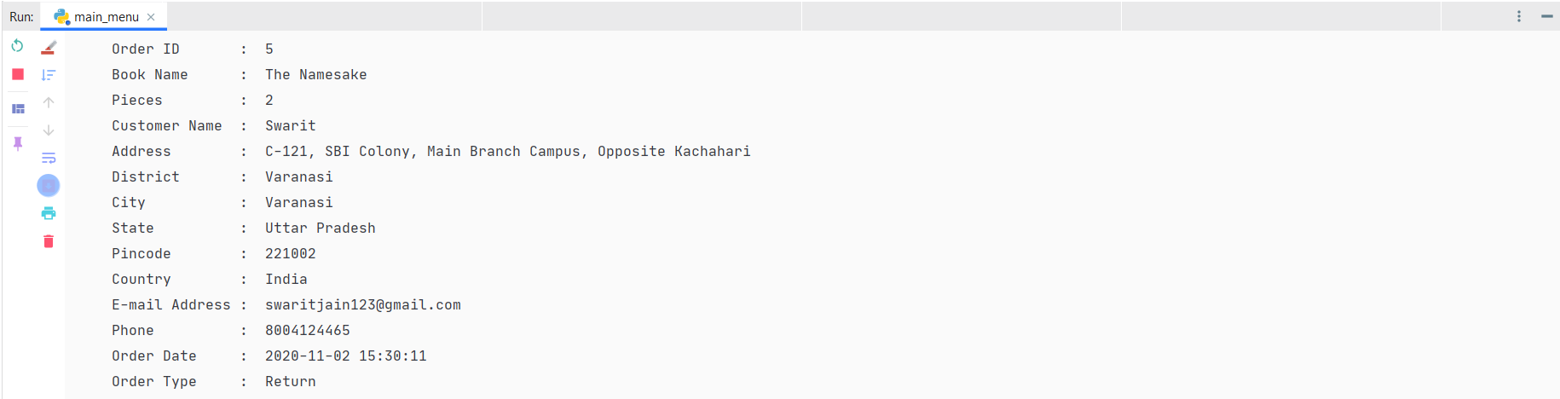

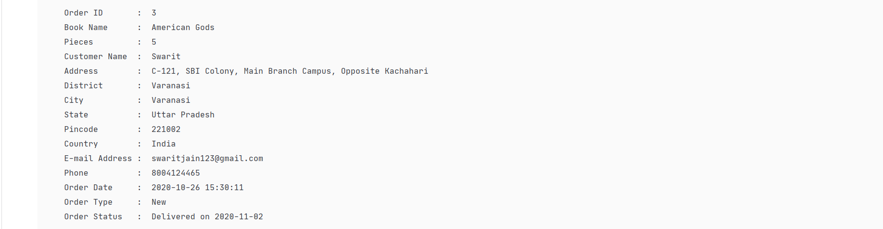

**View all Orders by date**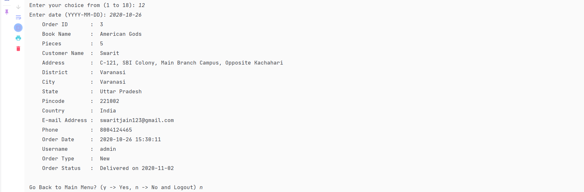

**Updating an Order Address**

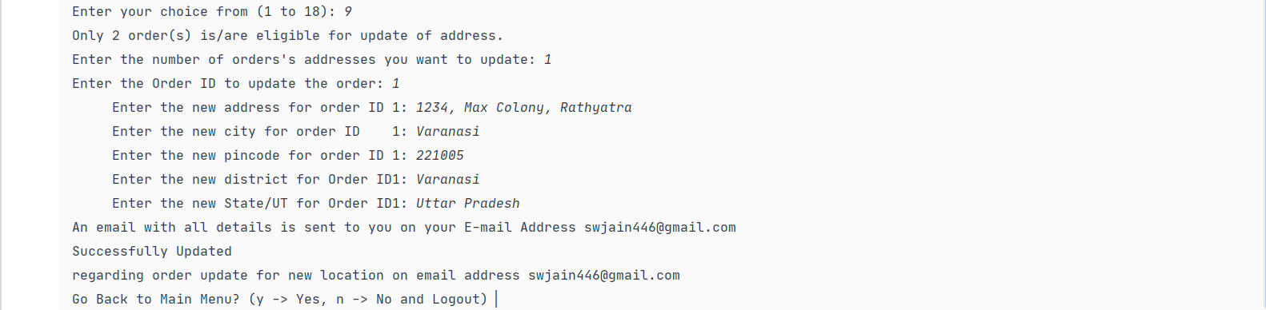

Note: - Here Order ID ‘1’ is of the testuser(sjain12sw).

**P.T.O**

**Email Sent on Order Address being Updated by Admin**

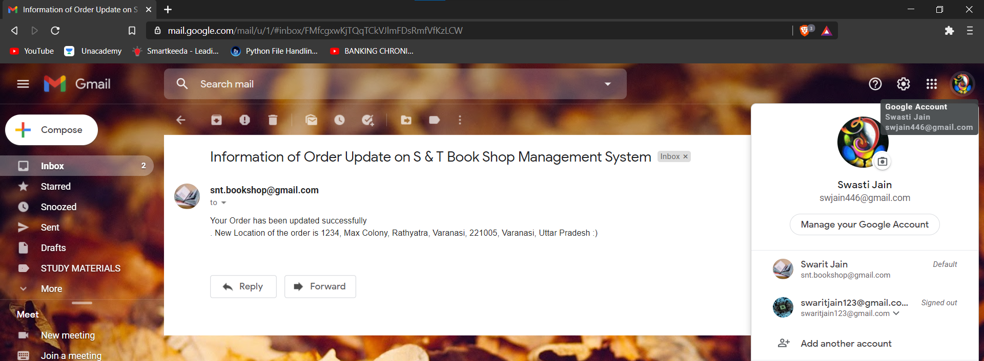

**P.T.O.**

**Cancelling an Order**

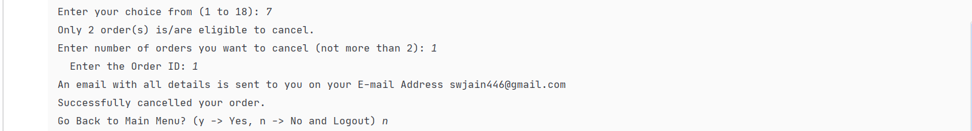

Note: - Here, order is being cancelled by admin and email is sent to the user’s email address on which the order was placed.

**P.T.O.**

**Email Sent on Order being Cancelled by Admin**

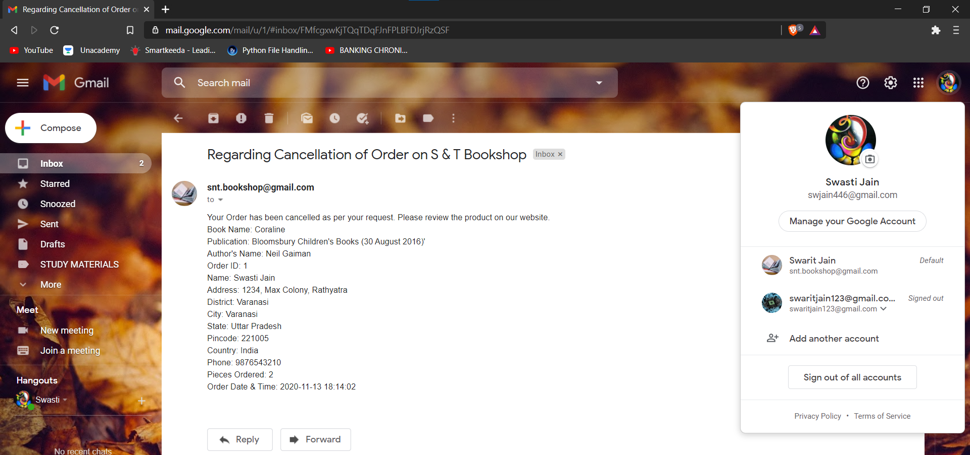

**Exiting from Administrator Block**

